

DA DIS User Verification User Guide



© 2017 DXC. Falls Church, Virginia. All rights reserved. No part of this publication may be reproduced by any means without written permission from DXC. Printed in U.S.A. All questions regarding this documentation should be routed through customer assistance, Blythewood, SC, 800-420-6007 or email [pcssupport@dxc.com](mailto:pcssupport@dxc.com).

# Introduction

Data Analytics Data Import System (DIS) User Verification screen is the interface through which the user manages to correct and update the failed data before it is finally imported into the RMA database.

* This enhancement is implemented in RMA 16.2. The key features of this enhancement are as follows:
* Ability to view the invalid data.
* Ability to view the valid data.
* Ability to correct the invalid data before importing.
* Ability to send the diary to RMA user when the user verification option is selected on the DA DIS Optionset window.
* Ability to resume the task with/without stopping verification.
* Ability to re-validate the failed data on resuming the task.

## User Verification Screen

The DA DIS Optionset window will contain a User Verification checkbox under optionset name which indicates if User Verification is to occur during the scheduled DA DIS job.

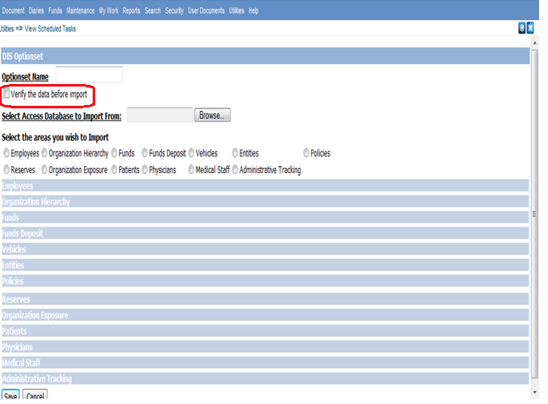

Figure 1: The DA DIS Optionset window

The DA DIS job will read the import file, assign global variables and validate the data. After the Validation of data flows are completed then if there are errors in the records given then the status of job will be “PENDING USER VERIFICATION” and a user diary will be sent to the user who scheduled the DA DIS job when the User Verification checkbox is selected. The user diary will contain a link to the User Verification screen. Diary can be opened from:

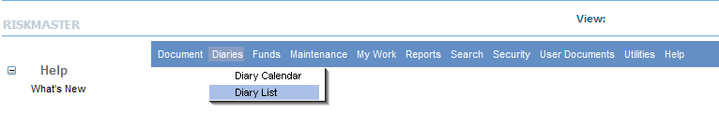

The User Verification screen will display all the records by default in the grid format. Selecting the View All Data radio button will display all DA DIS records for the particular job. When the Edit Failed Rows button is selected, the user can see only the failed records which can be edited.

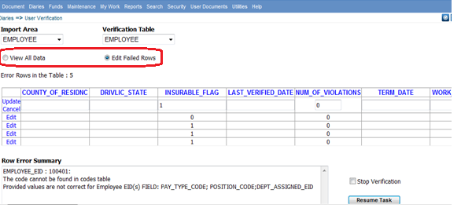

Figure 2: The User Verification window

After modifications are complete, the user will click on the Resume Task button and the job will again be executed. The data is stored in the DA_RMX_STAGING database.

If there are records that are still not valid, again user diary will be created again and sent to the user. This process will continue until all records are valid or the Stop Verification checkbox is selected.

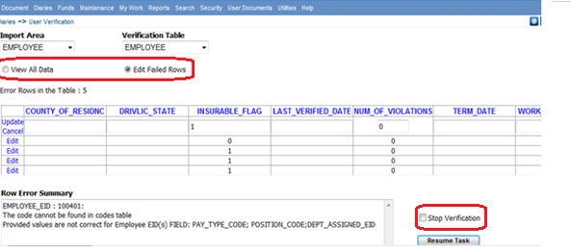

Figure 3: The User Verification window

When the Stop Verification checkbox is selected, the DA DIS job will immediately continue processing and import the valid records. The invalid records will be written to the DA DIS Error Log. A user diary will not be sent to the user when the Stop Verification checkbox is selected. The user needs to re-schedule a new DIS job to process the remaining invalid records.